**Nishant Patil**

**PG-DAC**

**Java**

**Assignment 5**

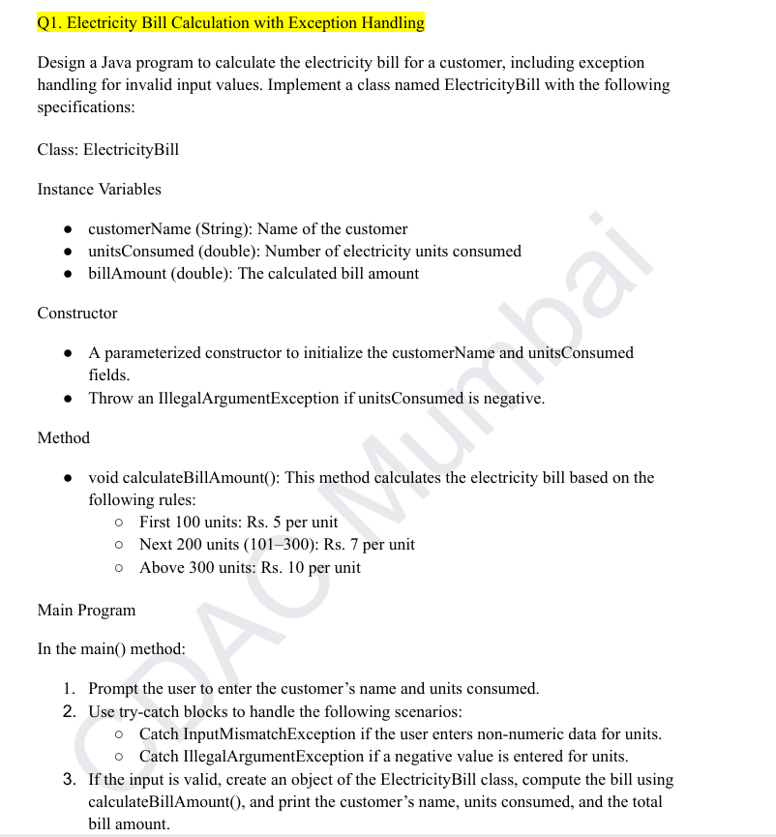

import java.util.InputMismatchException;

import java.util.Scanner;

class ElectricityBill {

private String customerName;

private double unitsConsumed;

private double billAmount;

ElectricityBill(String customerName, double unitsConsumed) {

if (unitsConsumed < 0) {

throw new IllegalArgumentException("Units consumed cannot be negative.");

}

this.customerName = customerName;

this.unitsConsumed = unitsConsumed;

}

void calculateBillAmount() {

if (unitsConsumed <= 100) {

billAmount = unitsConsumed * 5;

} else if (unitsConsumed <= 300) {

billAmount = (100 * 5) + ((unitsConsumed - 100) * 7);

} else {

billAmount = (100 * 5) + (200 * 7) + ((unitsConsumed - 300) * 10);

}

}

void displayBill() {

System.out.println("Customer: " + customerName);

System.out.println("Units Consumed: " + unitsConsumed);

System.out.println("Bill Amount: Rs. " + billAmount);

}

}

public class ElectricityBillDemo {

public static void main(String[] args) {

Scanner sc = new Scanner(System.in);

try {

System.out.print("Enter customer name: ");

String name = sc.nextLine();

System.out.print("Enter units consumed: ");

double units = sc.nextDouble();

ElectricityBill bill = new ElectricityBill(name, units);

bill.calculateBillAmount();

bill.displayBill();

} catch (InputMismatchException e) {

System.out.println("Error: Please enter a valid numeric value for units consumed.");

} catch (IllegalArgumentException e) {

System.out.println("Error: " + e.getMessage());

} finally {

sc.close();

}

}

}

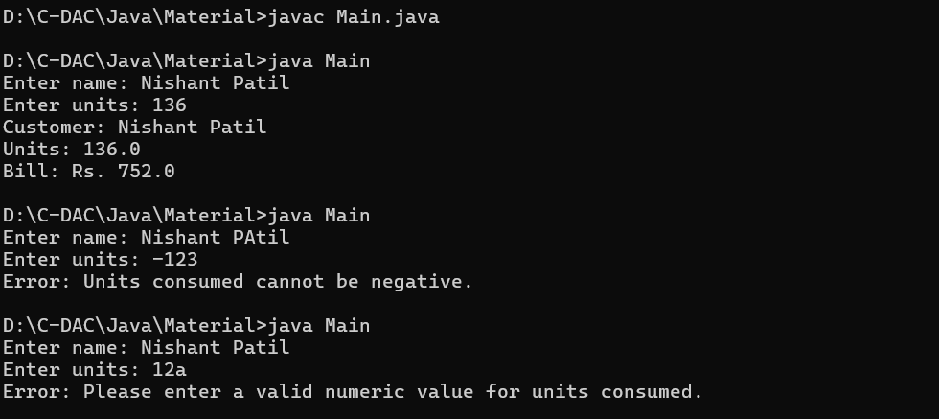

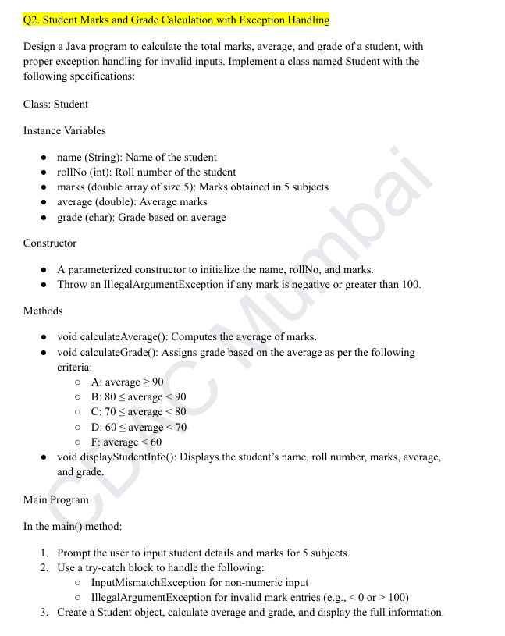

import java.util.InputMismatchException;

import java.util.Scanner;

class Student {

private String name;

private int rollNo;

private double[] marks;

private double average;

private char grade;

Student(String name, int rollNo, double[] marks) {

this.name = name;

this.rollNo = rollNo;

this.marks = new double[5];

for (int i = 0; i < 5; i++) {

if (marks[i] < 0 || marks[i] > 100) {

throw new IllegalArgumentException("Marks must be between 0 and 100.");

}

this.marks[i] = marks[i];

}

}

void calculateAverage() {

double sum = 0;

for (double mark : marks) {

sum += mark;

}

average = sum / 5;

}

void calculateGrade() {

if (average >= 90) {

grade = 'A';

} else if (average >= 80) {

grade = 'B';

} else if (average >= 70) {

grade = 'C';

} else if (average >= 60) {

grade = 'D';

} else {

grade = 'F';

}

}

void displayStudentInfo() {

System.out.println("Student Name: " + name);

System.out.println("Roll Number: " + rollNo);

System.out.print("Marks: ");

for (double mark : marks) {

System.out.print(mark + " ");

}

System.out.println("\nAverage Marks: " + average);

System.out.println("Grade: " + grade);

}

}

public class Main {

public static void main(String[] args) {

Scanner sc = new Scanner(System.in);

try {

System.out.print("Enter student name: ");

String name = sc.nextLine();

System.out.print("Enter roll number: ");

int rollNo = sc.nextInt();

double[] marks = new double[5];

System.out.println("Enter marks for 5 subjects:");

for (int i = 0; i < 5; i++) {

marks[i] = sc.nextDouble();

}

Student student = new Student(name, rollNo, marks);

student.calculateAverage();

student.calculateGrade();

student.displayStudentInfo();

} catch (InputMismatchException e) {

System.out.println("Error: Please enter numeric values for roll number and marks.");

} catch (IllegalArgumentException e) {

System.out.println("Error: " + e.getMessage());

} finally {

sc.close();

}

}

}

